

REPORT ON DESIGN WORKSHOP



Members: Andrei Agape, Cristian – Dan Cojocaru, Cristina – Ioana Simionescu, David Green, Yoana Zaharieva
Class: DM83
University: UCN
Date: November 9, 2012

CONTENTS

- Summary

This report covers The Designing, Programming and Testing of an Address Book Workshop made by Group 2. The goal was to design, implement and test an address book software by following the Address Book Handling System, the DVD Handling System, the Loan and the Return System. Using the information provided in the handouts and the documentation requirements, the group designed use cases, operation contracts, sequence diagrams, system sequence diagrams, the design class diagram and the code. The following pages describe the progress of the group work in completing the assigned tasks, as well as some considerations on how the group collaborated to achieve the goals.

- Main application functionalities

The application has to be able to:

- Handle the Address Book, which contains information about different people
- Handle DVDs, meaning storing a list of DVDs that can be rented
- Loan DVDs, which means a person can rent a copy of a DVD from the given list
- Return DVDs, which allows a person to end his loan

- Use cases

Having identified the 4 use cases (Handling of Address Book – given in the handouts, Handling of DVD, DVD is lent out and DVD is returned), the group managed to prioritize them. Consequently, Handling of Address Book and Handling of DVD were described fully-dressed, while Handling copies, DVD is lent out and DVD is returned were divided into brief use cases.

  - Use case: Handling of Address Book

Level:
User-Goal

Primary actors:
Private Person

Stakeholders and Interests:
Person wants to be able to register personal information, to change it, to get it and to delete it.

Preconditions:
User has program opened.
User wants to register in the address book.

Success guarantee (post conditions):
Personal information is registered in the address book.
Personal information can be accessed.
Personal information is modified.
Personal information is deleted.

Main success scenario:
- User opens the program.
- System asks for personal information.
- User inputs personal ID, name, address, postal code, and city and phone number.
- System saves the information to database.
- User accesses his information by inserting his ID.
- System displays the information.
- User wants to modify his personal information.
- System acknowledges the modification.
- User deletes the entry by inserting ID
- System deletes the entry.

Extensions:

2a: Same id entered
    - System asks for valid ID, ID already exists.
    - User types another ID.
2b: Same phone number entered.
      - System asks for valid phone number.
      - User types a valid phone number.
4a, 6a, 8a: ID not found.
    - System asks for valid ID.
    - User inserts a valid ID.

Frequency of occurrence: regularly

  - Use case: Handling of DVD
Level:
User-Goal

Primary actors:
Private Person (User)

Stakeholders and Interests:
User wants to be able to register a DVD in the system update and delete it.

Preconditions:
User has chosen to register DVD.

Postconditions:
DVD is registered in system.
DVD information can be accessed in the system.
DVD information can be modified.
DVD information can be deleted.

Main success scenario:
- User wants to create a DVD.
- User inputs DVD information id, title, artist, and publication date.
- System saves the information to database.
- User accesses the DVD by title.
- System displays the information wanted.
- User wants to modify the DVD information.
- System acknowledges the modification.
- User wants to delete DVD from system.
- System deletes the entry.

Extensions:

2a: DVD has already been registered in the system.
    - System prints that the DVD has already been registered.
    - User inserts new attributes.
4a, 6a, 8a: DVD is not found in the system.
    - System prints that DVD is not found in the system.
    - User inserts another title.

Frequency of occurrence: regularly

  - Brief use cases: Handling copies

Use Case (brief): Create a copy
A user wants to insert information for a copy of a DVD. He inputs serial number, purchase date and purchase price. The system saves the entry and adds the copy to the DVD class.

Use case (brief): Modify a copy
User makes changes in the information about the copy. The system saves the new information and implements the changes in the DVD class.

Use case (brief): Remove a copy
User wants to delete a copy. He enters the serial number. The system removes the chosen copy.

Use case (brief): Get copy information
User wants to receive information about the copy by inserting the serial number. The system prints out the details for the copy.

  - Brief use cases: DVD is lent out

Use Case (brief): Create a copy
A user wants to insert information for a copy of a DVD. He inputs serial number, purchase date and purchase price. The system saves the entry and adds the copy to the DVD class.

Use case (brief): Modify a copy
User makes changes in the information about the copy. The system saves the new information and implements the changes in the DVD class.

Use case (brief): Remove a copy
User wants to delete a copy. He enters the serial number. The system removes the chosen copy.

Use case (brief): Get copy information
User wants to receive information about the copy by inserting the serial number. The system prints out the details for the copy.

  - Use case: DVD is returned

- Operation contracts

The group then started creating the operation contracts that were identified depending on the needs of the application
  - Operation contracts: Handling of Address Book

Operation Contract: createPerson
Operation: createPerson(id: int, name: String, address: String, postalCode: int, city: String, phone: String)
Cross reference: Use Case: Handling of Address Book
Preconditions: None
Post conditions:
-An instance of Person is crated (instance creation)
-A Person is stored in the ArrayList<Person> in the Address book (association formed)

Operation Contract: getPerson

Operation: getPerson(id)
Cross reference: Use Case: Handling of Address Book
Preconditions: Person exists in the ArrayList<Person>
Postconditions:
- person.getPerson(id) – information about the person chosen is given

Operation Contract: updatePerson

Operation: updatePersonAddress(searched: int, address: String)
updatePersonCity(searched: int, city: String)
updatePersonName(searchId: int, name: String)
updatePersonPhone(searched: int, phone: String)
updatePostalCode(searched: int, postalCode: int)
Cross reference: Use Case: Handling of Address Book
Preconditions: The Person object has been found in AddressBook
Postconditions:
-person1.updatePersonAddress(searched: int, address: String) – address modified (attribute modification)
-person1.updatePersonCity(searched: int, city: String) – city modified (attribute modification)
-person1.updatePersonName(searchId: int, name: String) – name modified (attribute modification)
-person1.updatePersonPhone(searched: int, phone: String) – person modified (attribute modification)
-person1.updatePostalCode(searched: int, postalCode: int) – postal code modified (attribute modification)

Operation Contract: removePerson

Operation: removePerson(id: int)
Cross reference: Use Case: Handling of Address Book
Preconditions: The Person object has been found in the AddressBook
Postconditions:
- person1.removePerson(id) – person is removed from the AirrayList<Person> (association formed)

  - Operation contracts: Handling of DVD

Operation Contract: addDVD
Operation: addDVD (id: int, title: String, artist: String, publicationDate: String)
Cross reference: Use Case: Handling of DVD
Preconditions: none
Postconditions:
- A new instance of DVD is created. (instance creation)
- The instance is stored in ArrayList<DVD> in DVDcontainer class (association formed)
- Attributes of the object are initialized.

Operation Contract: modifyDVD
Operation: modifyDVD(id: int, title:String, artist:String, publicationDate:String)
Cross reference: Use Case: Handling of DVD
Preconditions: The DVD has been found in ArrayList<DVD>
Postconditions:
- DVD.changeArtist(id) – artist is modified
- DVD.schangeId(id) – id modified
- DVD.changePublicationDate(id) – publication date modified
- DVD.changeTitile(id) – title modified
- Attributes are modified.
Operation Contract: removeDVD
Operation: deleteDVD(id: int)
Cross reference: Use Case: Handling of DVD
Preconditions: A DVD has been found in ArrayList<DVD> in DVDcontainer class.
Postconditions:
- DVD.removeDVD(id) – the DVD chosen is removed from the Array List of DVDs.

  - Operation contracts: DVD is lent out

Operation contract: createLoan

Operation: createLoan()
Cross reference: Use Case (brief): Creating a loan
Precondition: None
Postcondition: - An instance of Loan is created
- The instance is stored in ArrayList<Loan> in the LoanContainer class
- Attributes of object are initialized

Operation contract: getLoan

Operation: getLoan()
Cross reference: Use Case (brief): Viewing details about a loan
Precondition: A loan has been found in ArrayList<Loan> in Loancontainer class.
Postcondition: Attributes of Loan object are returned

Operation contract: modifyLoan

Operation: modifyLoan()
Cross reference: Use Case (brief): Changing loan details
Precondition: A loan has been found in ArrayList<Loan> in Loancontainer class
Postcondition: Attributes of Loan object are modified

Operation contract: deleteLoan

Operation: deleteLoan()
Cross reference: Use Case (brief): Canceling a loan
Precondition: A loan has been found in ArrayList<Loan> in Loancontainer class.
Postcondition: Loan object is deleted from the ArrayList<Loan> in Loancontainer class

  - Operation contracts: DVD is returned

- Sequence diagrams
  - Address Book sequence diagrams
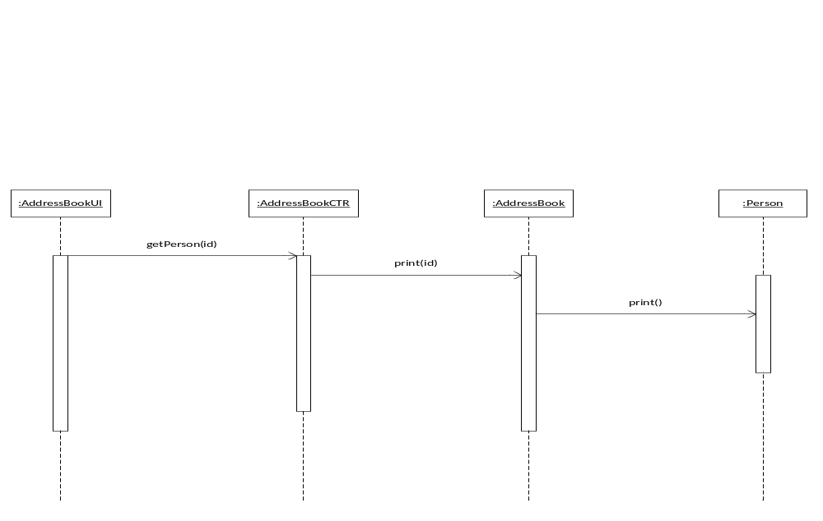
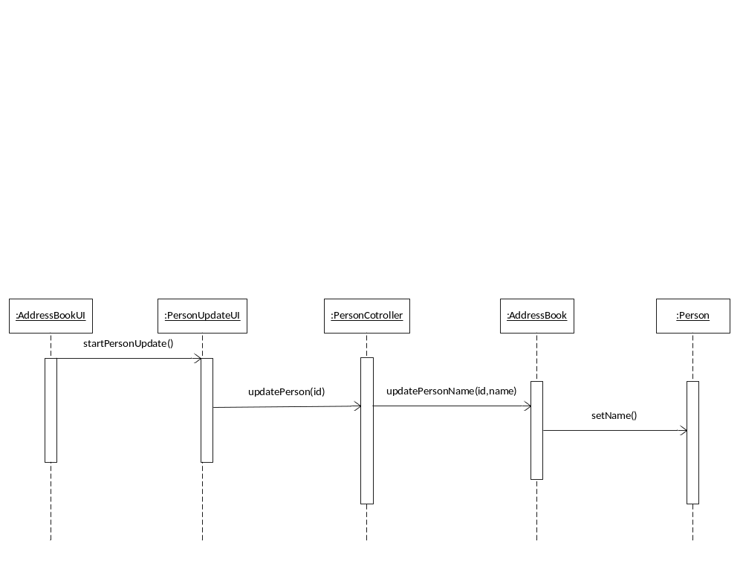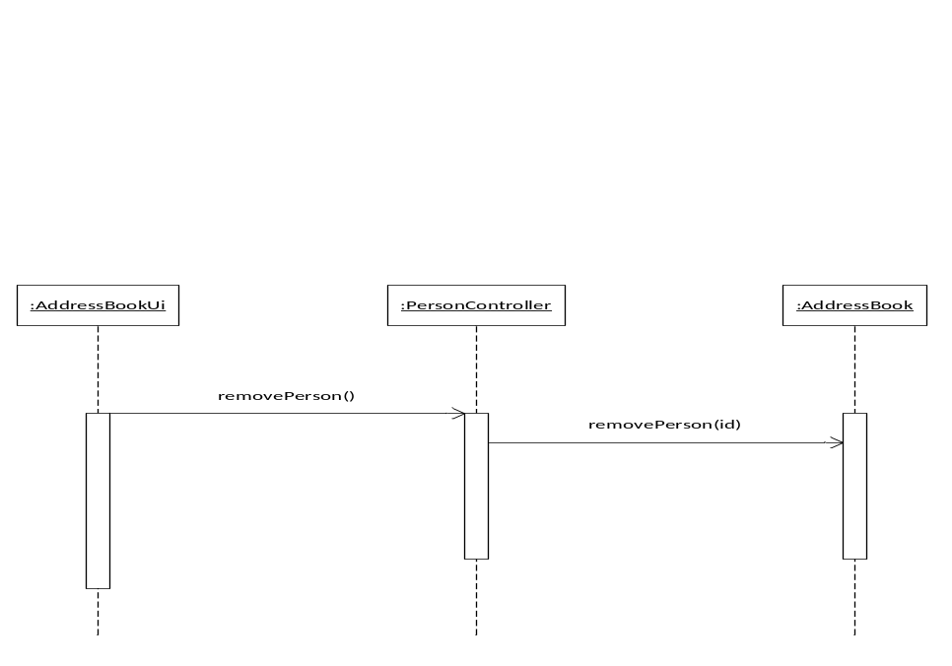

  - Handling of DVD sequence diagrams
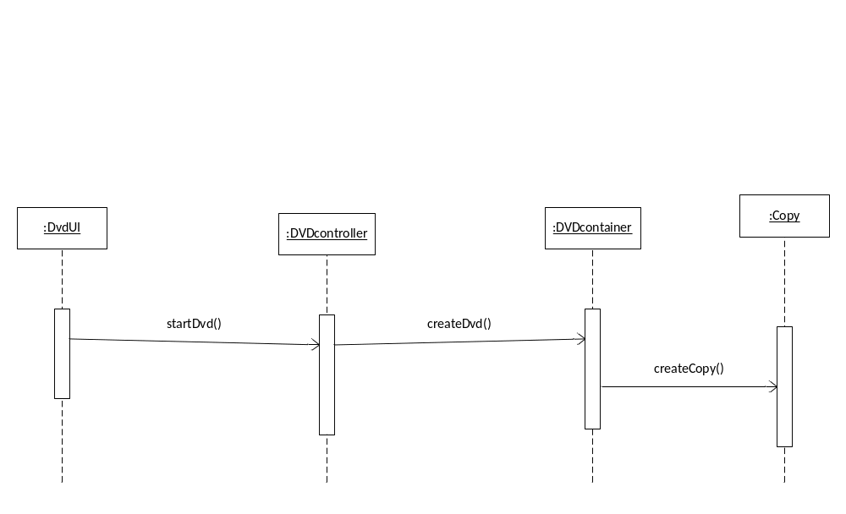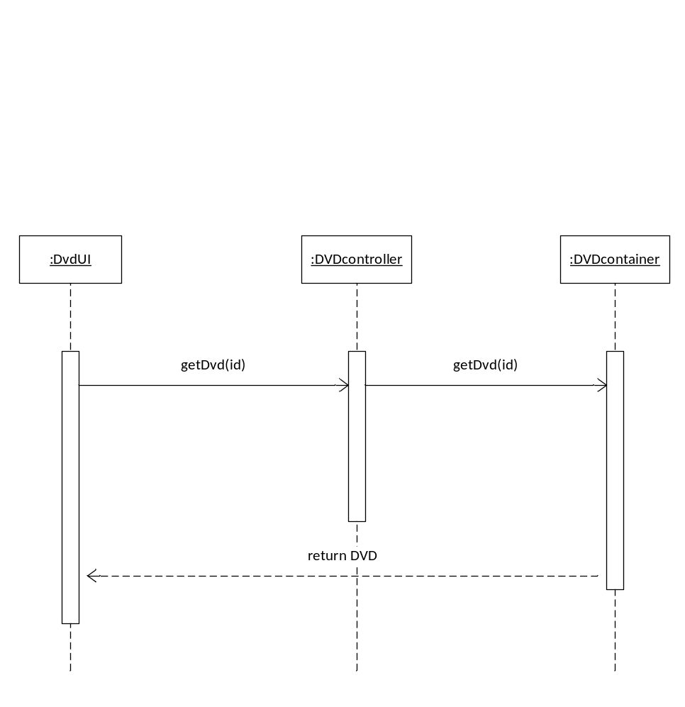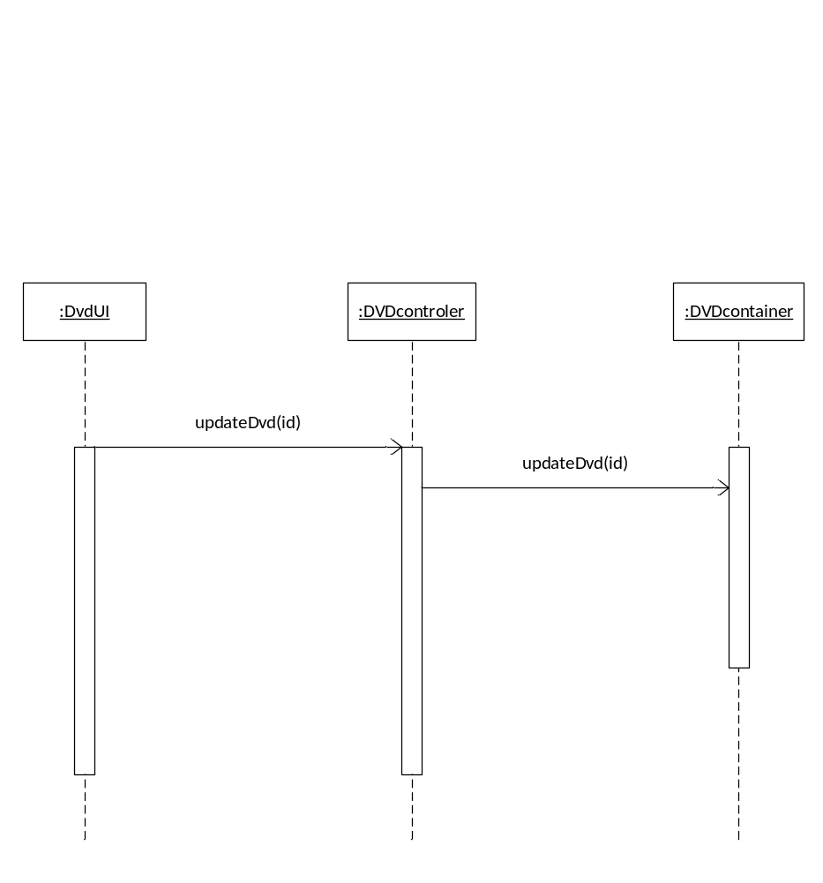
  - DVD is lent out sequence diagrams
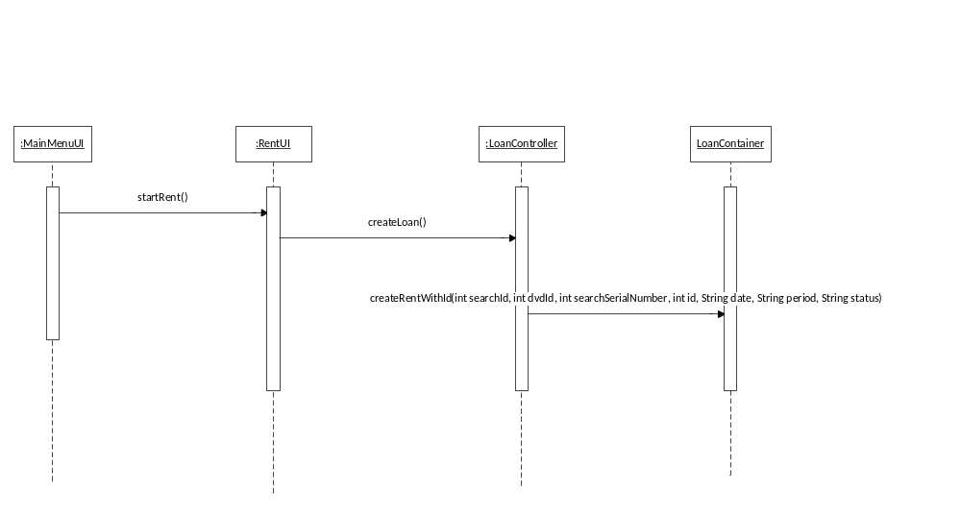
  - DVD is returned sequence diagrams

- System sequence diagrams

  - Handling of DVD system sequence diagrams
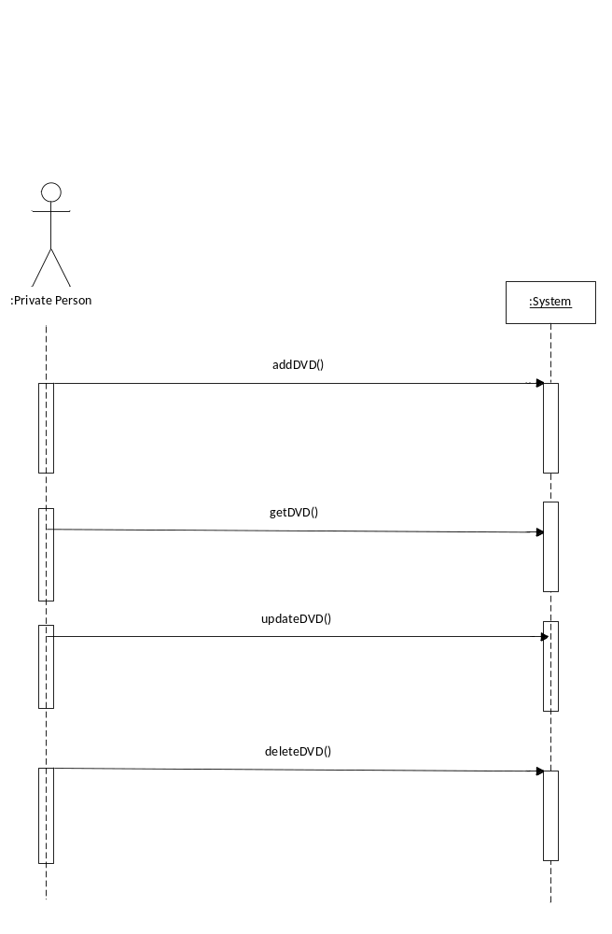
  - DVD is lent out system sequence diagrams 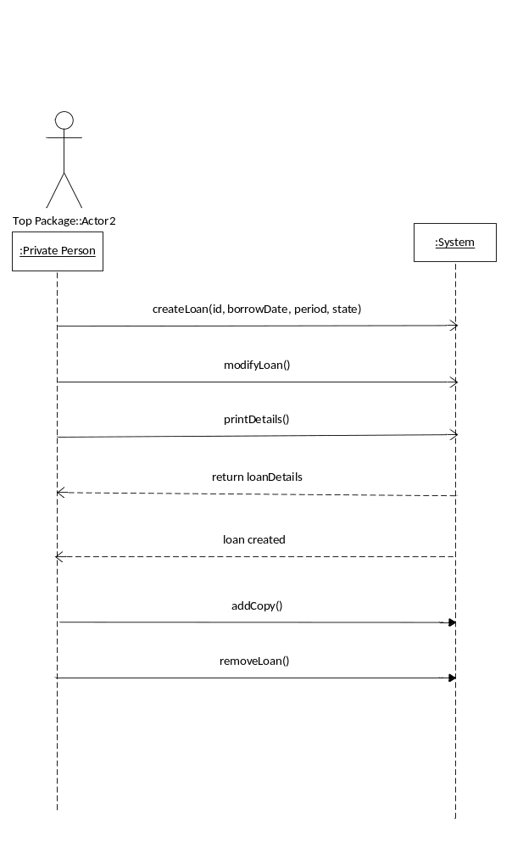
  - DVD is returned system sequence diagrams

- Design class diagram

